***The code i built you is supposed to be a fake instagram used to gather instagram account infos. I also made you an email to go with it. Email:***

[***jimcrow1032@proton.me***](mailto:jimcrow1032@proton.me)

***jimcrow1***

***I’ll attach the scripts in the email.***

***When you download the zip you will need to unzip it. Once you do that you’ll go to “instagram form tutorial” folder and once you open it, you’ll see this:***

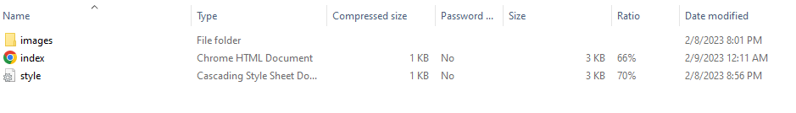

***Index has your html, styles has your css, and images has your logos. In order to run them you’ll need to make an account with github. MAKE SURE YOUR GITHUB NAME IS RELATED TO INSTAGRAM (ex: instagramlogin2, logininsta, etc.) Once you make an account you’ll follow these steps:***

***Find a way to go to make a repository. This will contain your code.***

***Then for your first project you will want your title for it to be as close as possible to your username. Then add “.github.io” behind it so it makes a website. (ex: logininsg.github.io)***

***Make sure your repository is public so you can make it a site.***

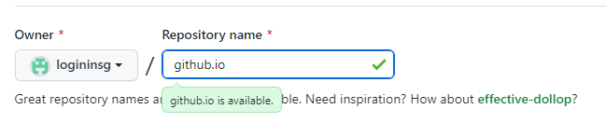

***See how i didn’t even add anything to it. Keep it as short as possible but make sure they dont look suspicious.***

***Then hit create. You dont need a readme file or license btw skip that.***

***Then look for this and click upload existing:***

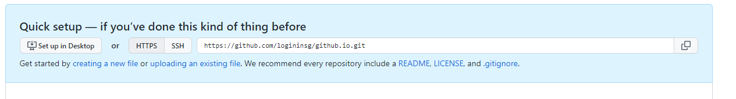

***Then click choose your files, navigate to the correct place that has your styles and index and select them. YOU CANT DO IMAGES JUST YET (it wont allow you).***

***Scroll down and hit commit changes.***

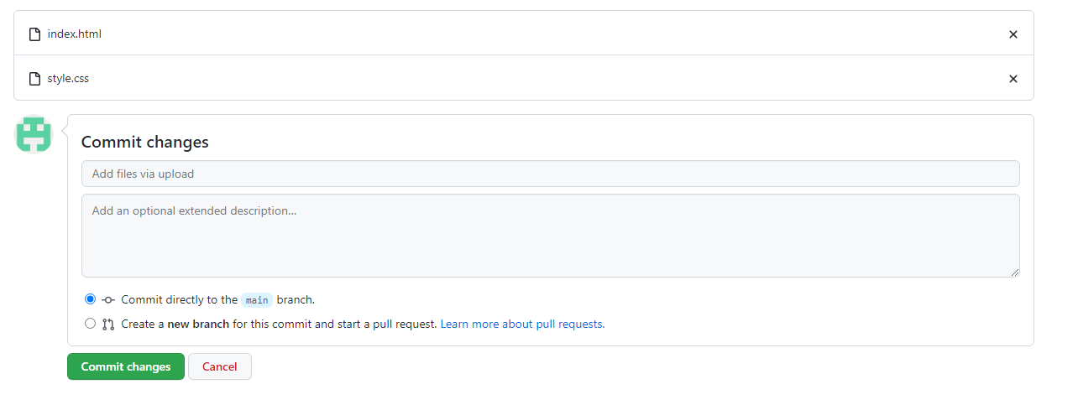

***Once you do that you’ll see them in the directory. Once you do that go to add files >>> create new. This is how you will add your images.***

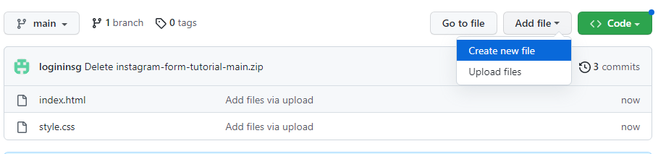

***In this box at the top type in “ images/ “. That will make it a folder.***



***Then type empty because this one file will be empty.***



***Scroll down and commit it.***



***It should direct you to this:***

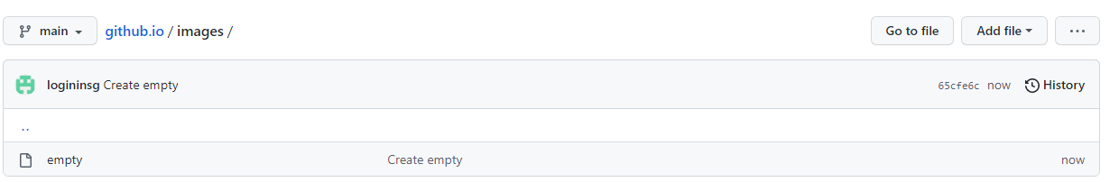

***Go to add files >>> upload files. Look for images.***



***Then select all the photos.***

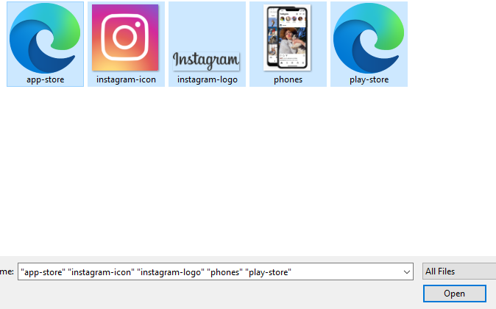

***And commit them once they upload.***



***It should look like this:***

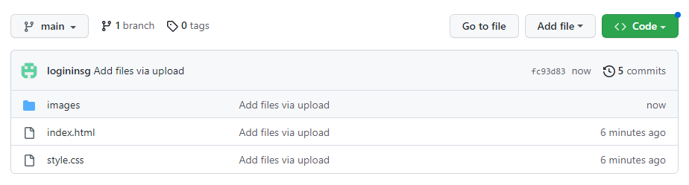

***Now in the top go to settings:***

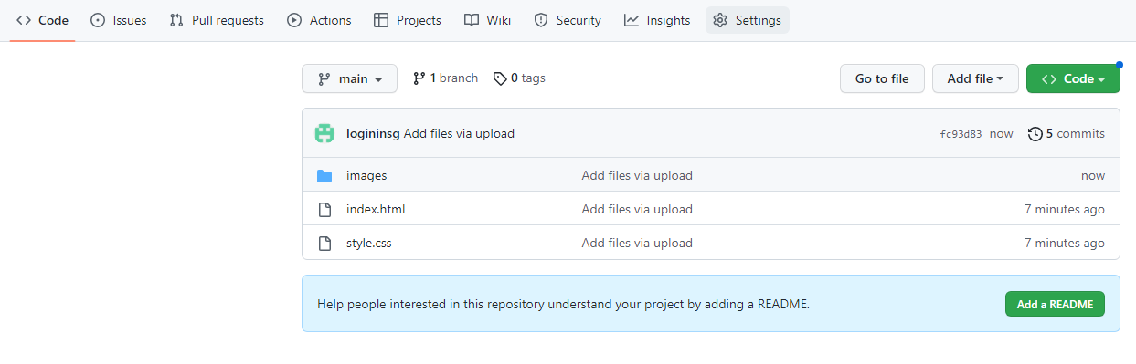

***\*\*next page\*\****

***Go to Pages:***

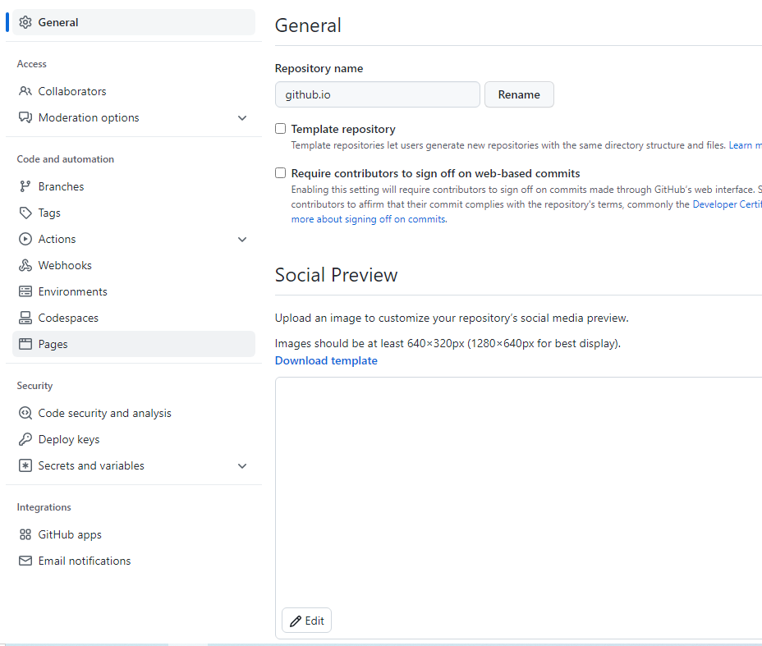

***Go under branch and hit main.***

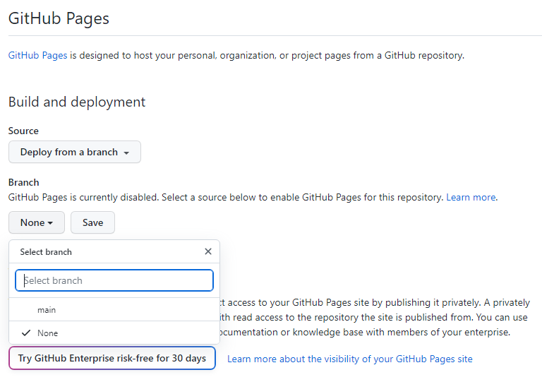

***After main hit save. This make a link in a couple of minutes.***

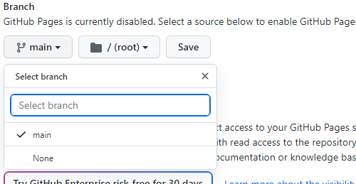

***Make sure u hit save.***

***Under Pages you should have a link in a couple of minutes. Refresh your browser.***

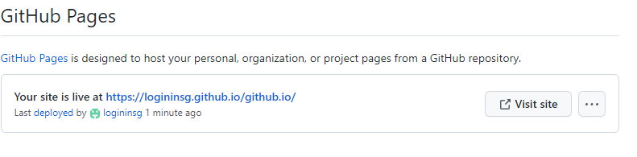

***Hit visit site and you’ll see what ive done. SINCE THIS IS FIRST TIME THE LINK HAS BEEN USED you will have to try it out with dummy info.***

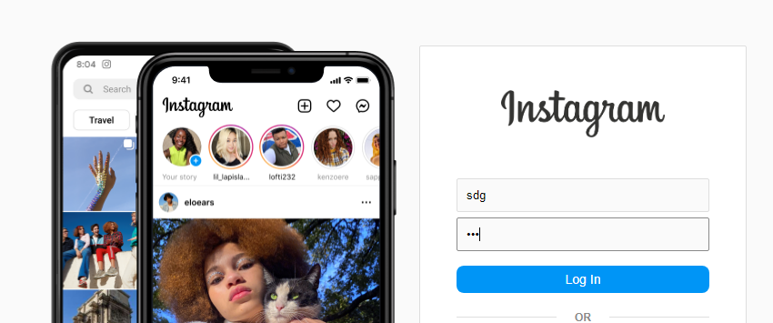

***Look at this link:***



***See the white part not including “.github.io”. (logininsg). Every time that part changes you should try out your link because you will probably have to reactivate it.***

***Once you hit login you should see this if its a new link:***

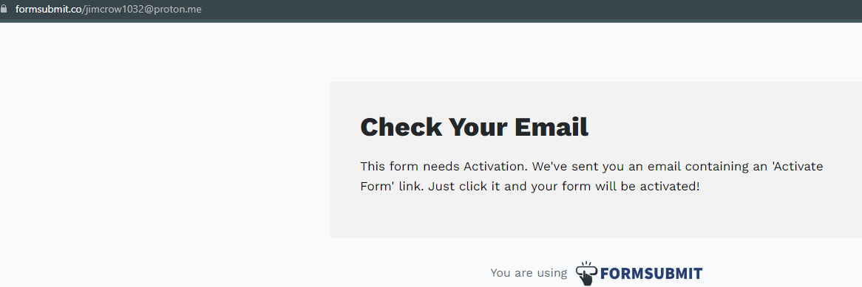

***Check ya email for this email:***

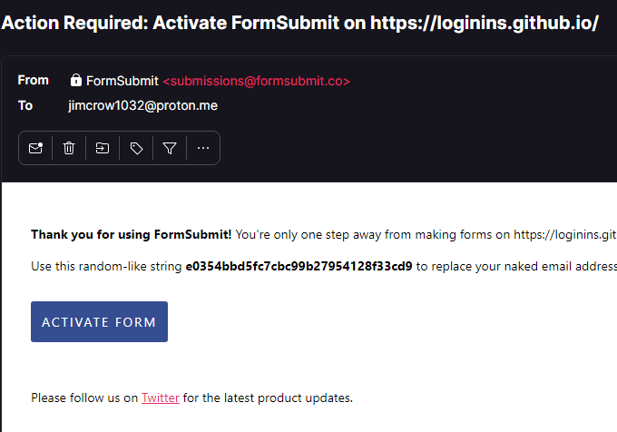

***Hit activate to get ya link fixed.***

***If you see this then click on the link:***

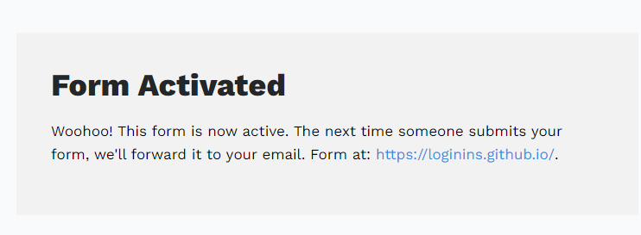

***You will probably see this so literally ignore it:***

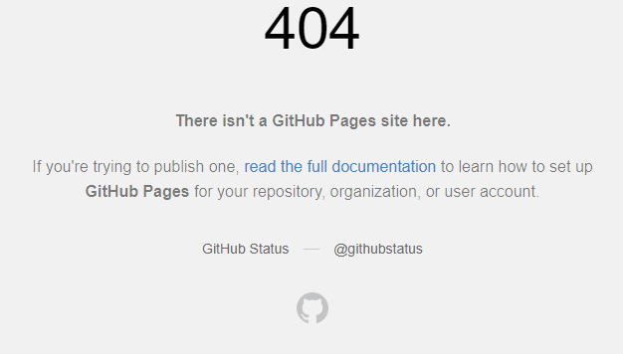

***Once you leave that, go back to git hub, settings, pages, then go to your link. Type in sum more dummy login info and it should redirect you to instagram. Now check your email, what do you see?***

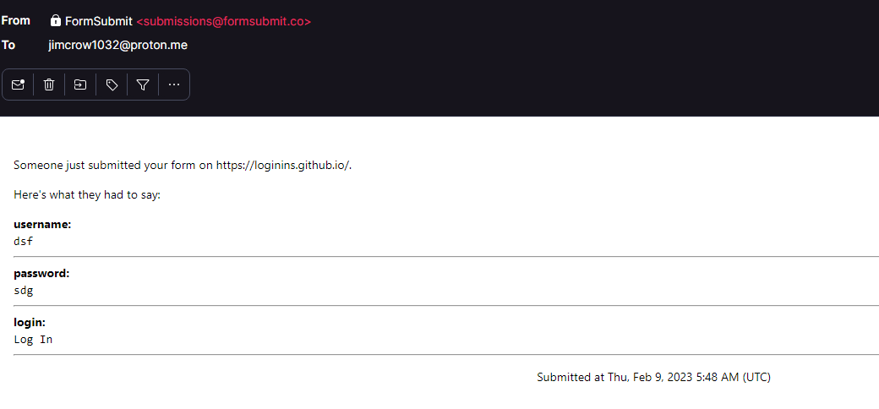

***Oh wow it works.***

***But this link will eventually burn. Google will flag it as shitty and everyone that goes to the link will see a big red website saying caution.***

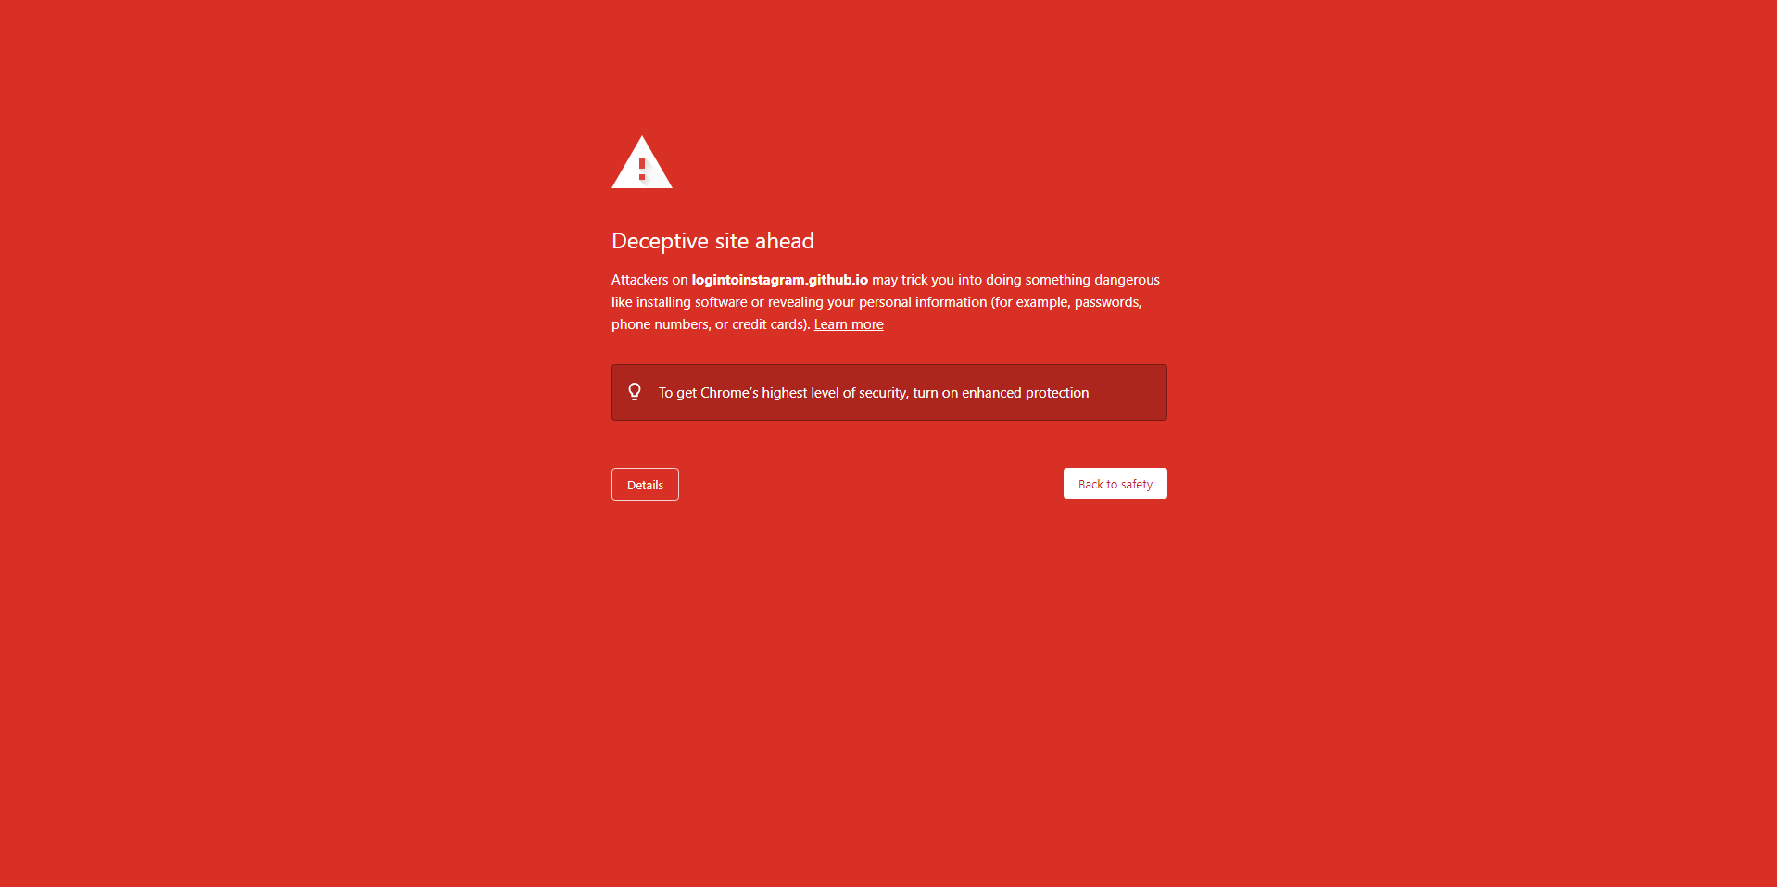

***If that happens then its time to change your username.***

***Go to the top right corner:***

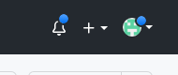

***Click on your icon and go to your settings and then account.***

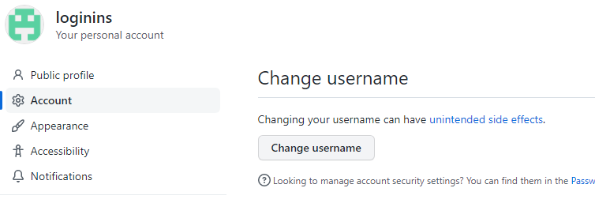

***Change username so its barely different and still looks like an instagram link.***

***Then go to the upper right icon, hit your repositories.***

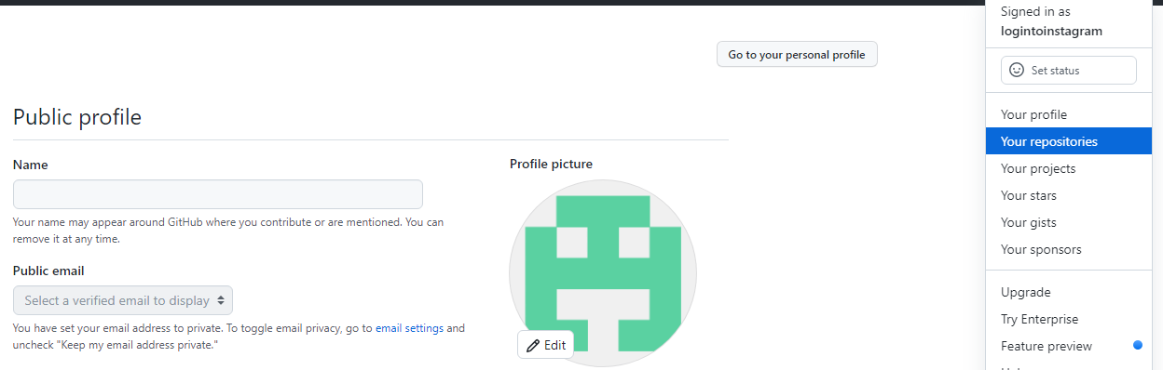

***Notice how my project from earlier is up their and my username is different. You will not have to touch that project just open it, go to settings, pages, and you should already have a brand new link.***

***Now since its new, you need to enter dummy info, check your email and reactivate it. Try more dummy info and see if it sends. Then your good to go until it burns again.***

***Rinse repeat.***

***The best way to insta fish is to send your self a instagram link ss the thumbnail or image and just write a text that says login to use. Maybe open snapchat and farm people as friends and send them link once yall know each other. Or say they’ev had a suspicious login from hell or something.***

***Thw Google code is the same process and i recommend using an account for each method (insta or google) so when the link gets listed both links wont crash. The google folder contains one file called index.html which is all you need. REMEMBER TO ALWAYS TEST YOUR LINKS WITH DUMMY INFO FIRST SO THEY’LL WORK. if they dont lmk.***

***Same thing google one just send a link about something and they’ll think they need to login to use.***

***You may notice that the email actual gets sent to two addresses and the second address is just a server one so your email wont be traced first. (protective feature). Use whatever you think you’ll need like a vpn or tor when you check your email. By using my code you also agree that I am not liable for anything that happens to you or anyone I made the code for EDUCATIONAL PURPOSES.***

***If you would like your email changed then dm me or email me. If you have any questions reach out.***

***Use numbers in names to have infinite accounts. (loginform10032, loginform11032, etc)***